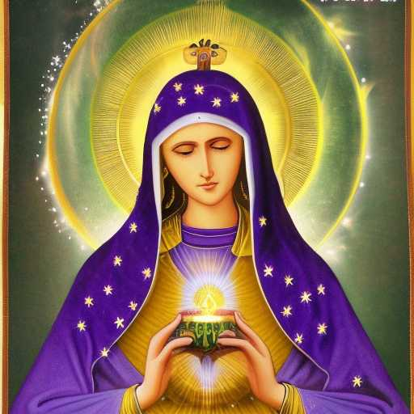
FLAMING PURPLE LOTUS

The Blessed Virgin is the Immaculately Beautiful Woman, seated in the lotus position upon a flaming purple
lotus, as her crown beams love and light up and out towards a myriad of stars

She flies with the wings of Ma'at

She is Zion, majestic in Tiphereth, with streams of living water pouring forth from her Sacred, Flaming Heart

Weeping willows shimmer with sun shafts

